**CS205: Information Security**

**Semester: Fall 2021**

**Assignment No. 03**

**Solution:**

**Question No.1:**

Download “Google Chrome Browser STIG (Security Technical Implementation Guide)” from DISA STIG List and harden Google Chrome Browser to implement following security configurations:

1. **The running of outdated plugins must be disabled.**

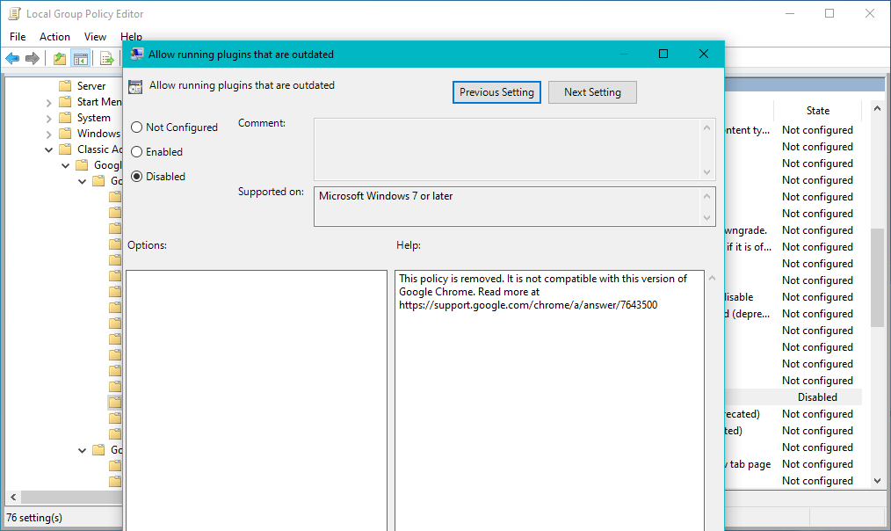

1. **Incognito mode must be disabled.**

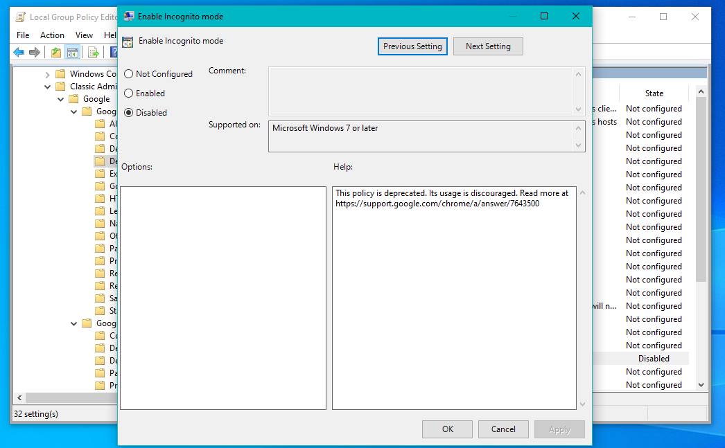

1. **Search suggestions must be disabled.**

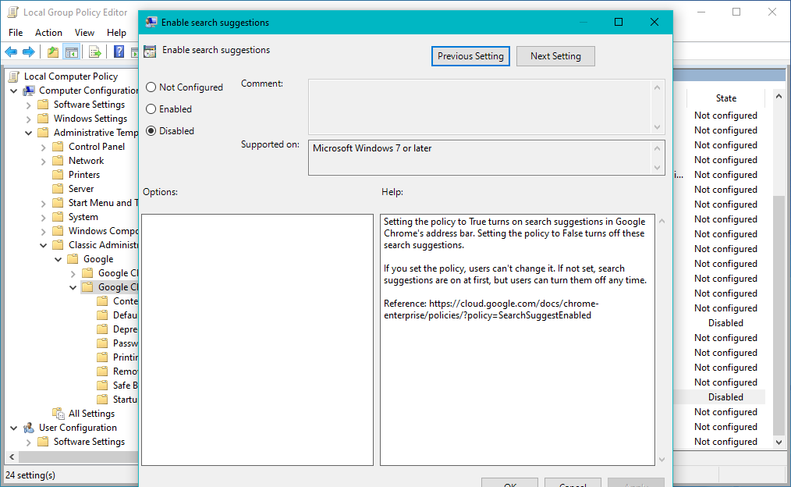

1. **Importing of saved passwords must be disabled.**

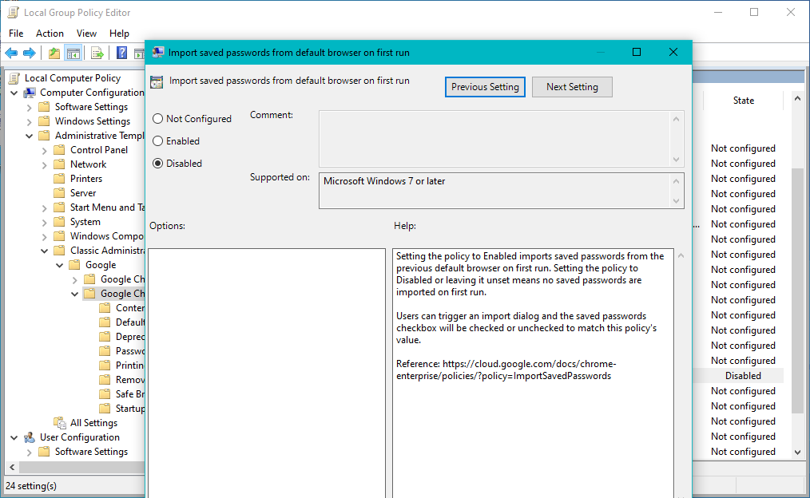

1. **Browser must support auto-updates.**

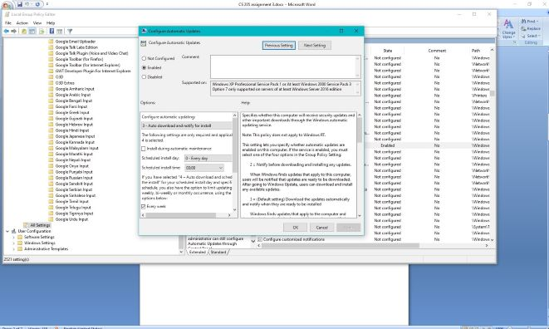

**Question No.2:**

You are required to download CIS benchmark for Mozilla Firefox browser and then harden the browser to implement the following security configurations:

According to the CIS benchmark:

1. **Enable Information Bar for Outdated Plugins**

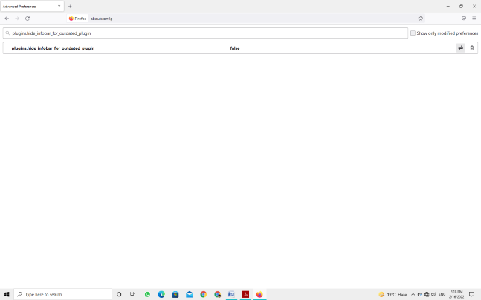

1. **Enable Warning For "Phishy" URLs**

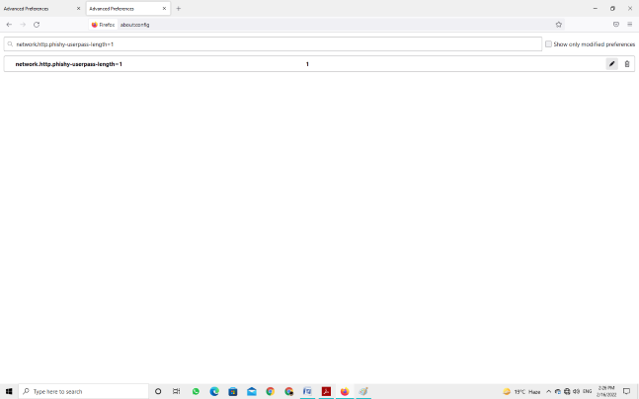

1. **Disallow JavaScript's Ability to Hide the Status Bar**

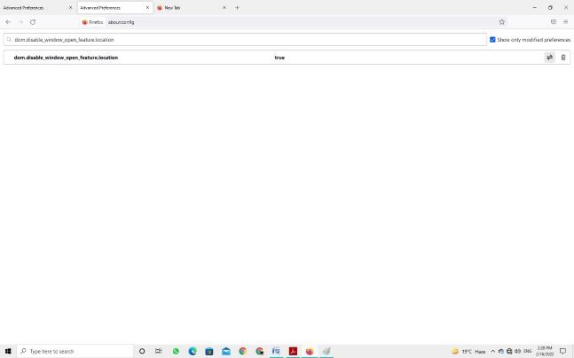

1. **Do Not Accept Third Party Cookies**

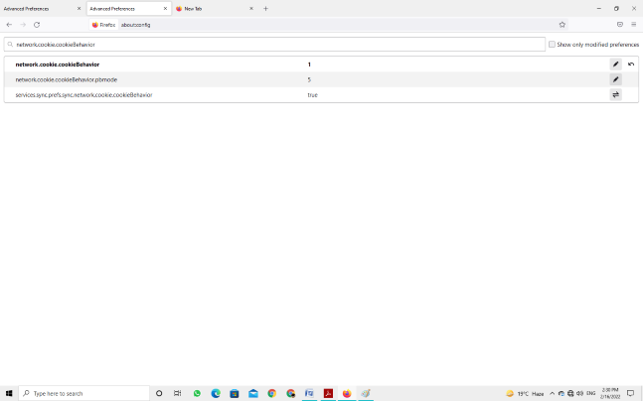

1. **Disabling Auto-Install of Add-ons**

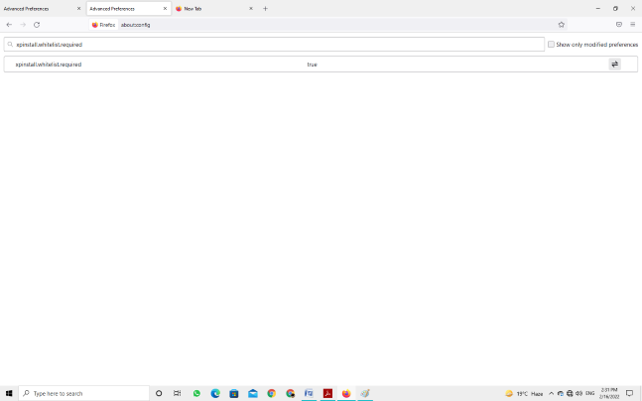

1. **Disable Popups Initiated by Plugins**

